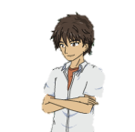
Hi, nǐ jiào shén-me míng-zì?

wǒ xìng wáng, jiào wáng yuè. nǐ ne?

Wǒ xìng Li, jiào Li Jié Fu.

Jeff shì nǐ-de yīng-wén míng ma?

.

Shì.

Chinese | English | Chinese | English
Xìng | (one’s) last name is…
Jiào | Call or to be called
shén-me | what
míng-zì | Name
nǐ ne? | What about you?
shì | am/ is/ are
yīng-wén míng | English name
Vocabulary Patterns
Grammar & Patterns

一Asking about names
- Tā jiào shén-me míng-zì? (What does he call? or What’s his name?)
- Zhè běn shū (This book) jiào shén-me míng-zì？
(What does this book call? or What’s this book’s name?)
Noun + jiào shén-me míng-zì? (What does he call? or What’s his name?)

二 Telling names of sb or sth.
- Tā xìng wáng, jiào Wáng Yuè. [Her last name is Wang, (her name) is Wang Yue]
- Zhè běn shū (This book) jiào 《Ha li Bo Te》(This book is called “Harry Potter”)

Sb + xìng + last name, jiào+full name. [My last name is… (my) name is..)]

三 Asking yes/no questions.
- Zhè shì nǐ-de ma? (This is yours? / Is this yours?)
- Zhè shì nǐ de ma? (You are a teacher? / Are you a teacher)

Affirmative Sentences ＋ ma? (“ma” at the end of a sentence is a questions marker in Chinese.)

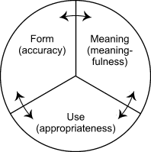
Three important elements when learning grammar in any languages:

Picture from Larsen-Freeman, D. (2003). Teaching language: From grammar to grammaring.

